User Manual

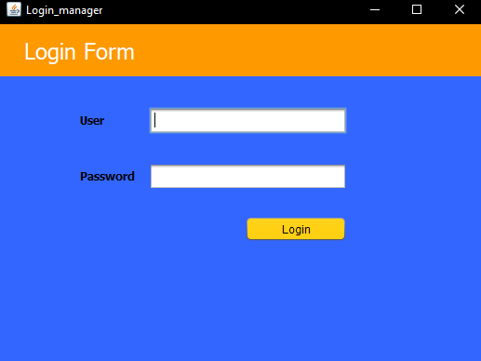

When the application is launched you are greeted with a log in page. Sign in with your credentials.

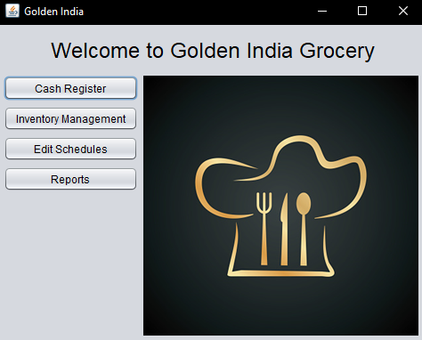

You will then be greeted with the main navigation screen. From here there are many functions that can be used. Let’s work our way from top to bottom. First the cash register.

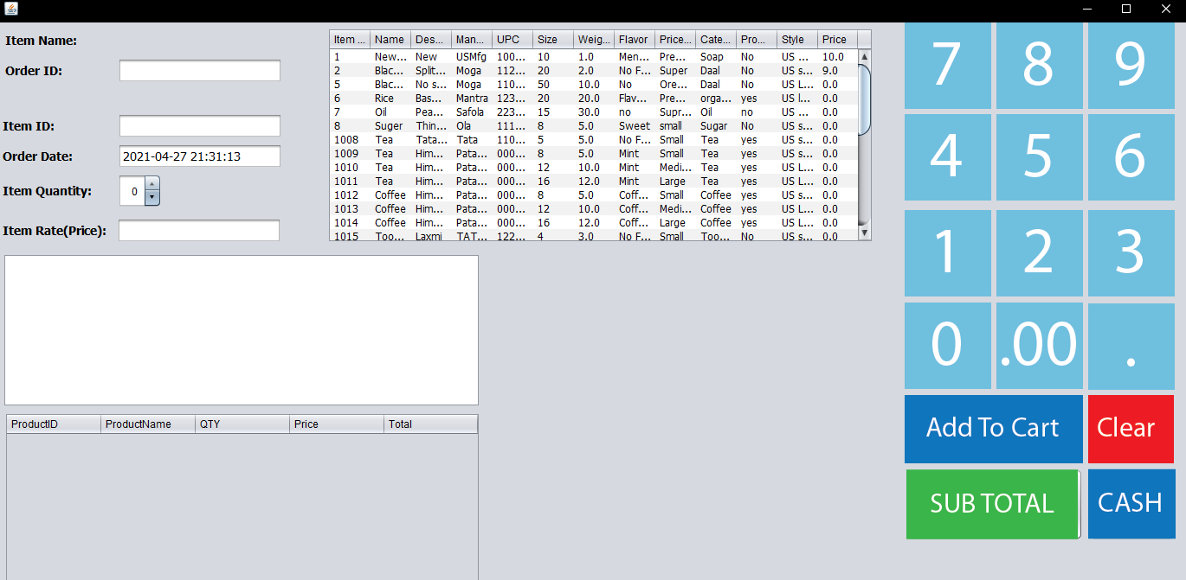

After clicking cash register you are greeted with this screen. You will now need to select an item from the list that the customer is purchasing.

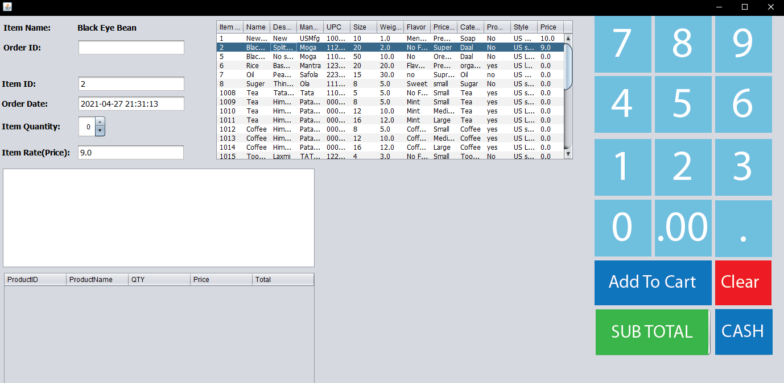

Now the Item Name, ID, and price will be automatically filled. The next step is to enter an Order ID Number and update the quantity.

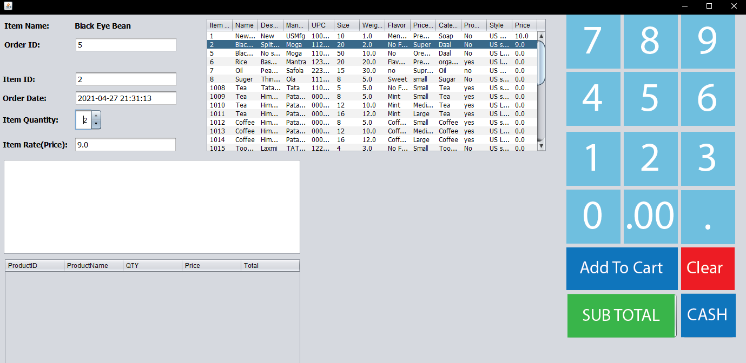

Now that this is done you need to click add to cart.

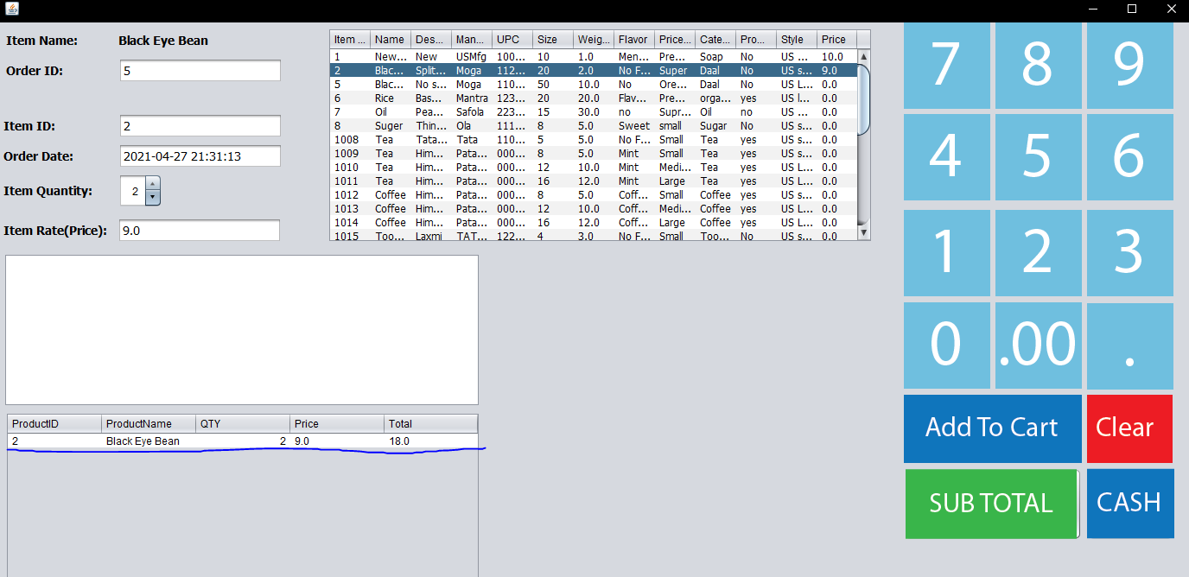

The product has been added to the cart. Now you may either select a new item and repeat the steps or if the order is complete click the subtotal button. We will now click the subtotal button.

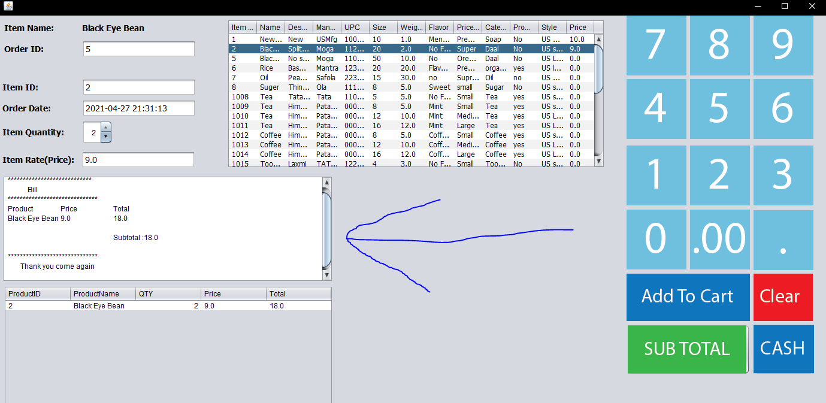

This updates the receipt and the customer is now ready to pay. The next step is to click cash and the order will be processed and stored in the database and the item sold will be updated in inventory.

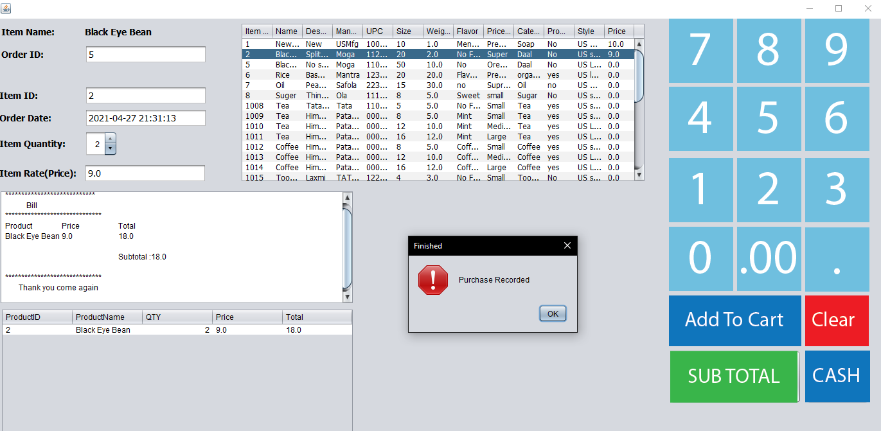

At this point click ok and close the cash register.

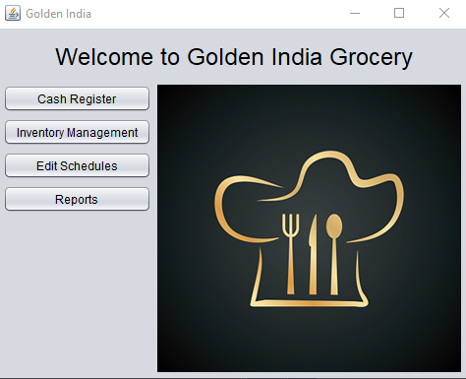

Now you are back at the home screen. Click inventory management for options regarding inventory.

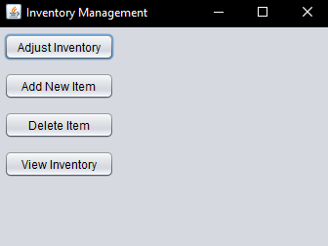

This screen provides all of your options regarding inventory. Lets start from the bottom because it has useful information that may be needed for other options. Click View Inventory.

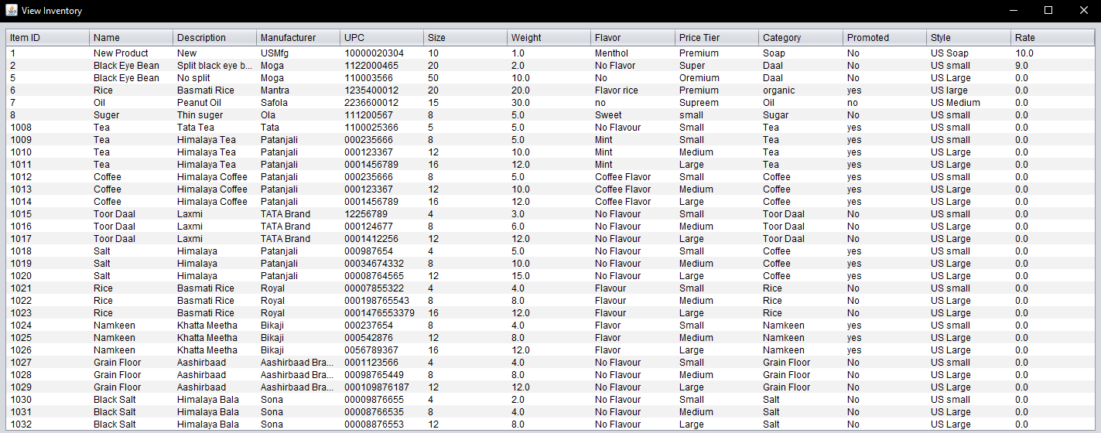

This screen is displayed which gives you all of the information about items currently in the database. It is the quickest way to get an item id or UPC which may be needed for updating or deleting an item. You can close this screen now.



Back on the main screen click on adjust inventory.

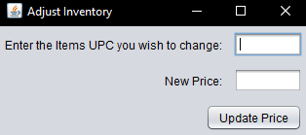

You will be greeted with this screen. Enter the UPC of an item that you would like to update and then enter the price.

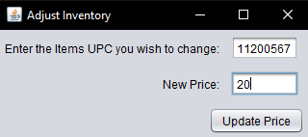

From here click Update Price.

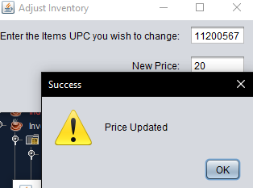

If everything is correct you will be shown a box saying that the price is updated. Click ok and close the adjustment screen.



You will be back on the main inventory screen now click on view inventory to see the updated price.

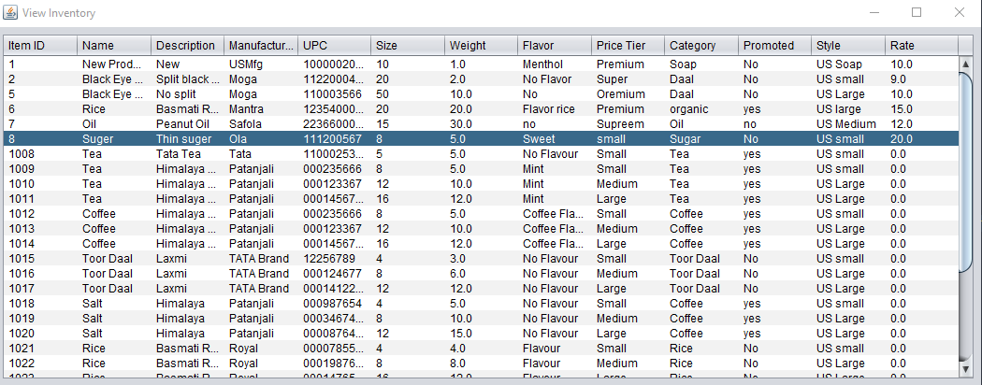

You can close this out and go back to the main inventory screen again.



Click Add New Item.

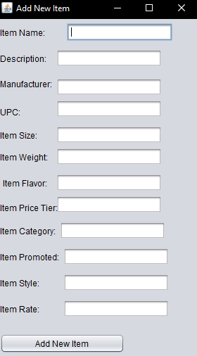

The add new item screen appears please fill in all information.

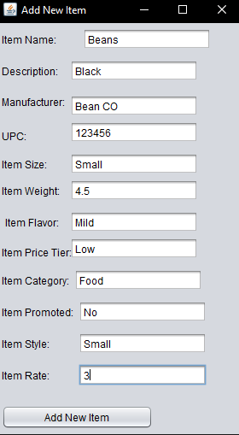

With all of the information filled in click add new item.

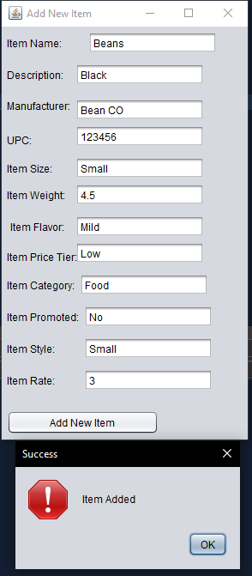

This screen indicated that the new item was added. Close out the screens and go back to view inventory to see your new item.

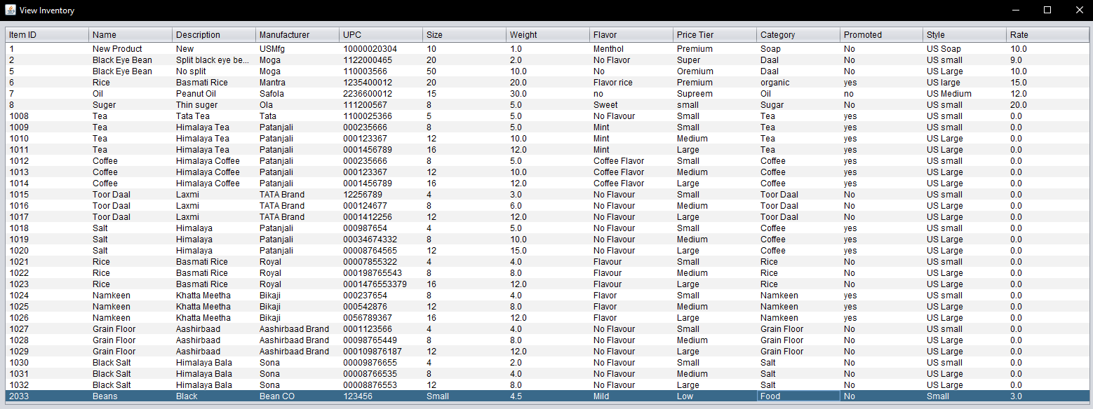

Here you can see the new item has been added.



Back on the main screen click on Delete item.

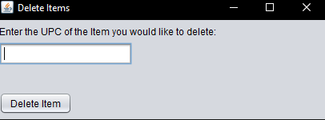

Enter the UPC of the item you no longer need.

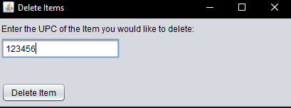

Once you have done that click Delete Item.

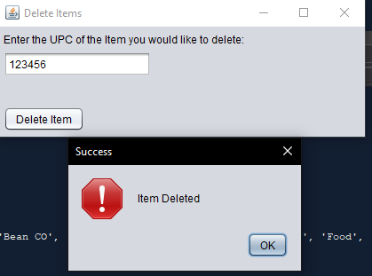

The item has been deleted and you can now close this page out.

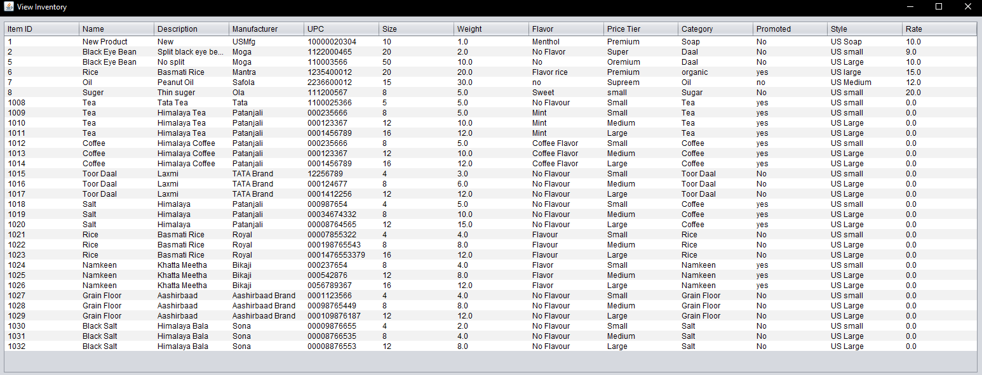

The item is no longer on the view inventory page.



Back on the home screen click on Reports

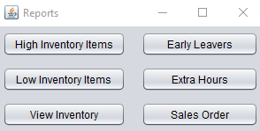

This screen has 6 different reports that you can load. I will show a shot of all screens with the button name included.

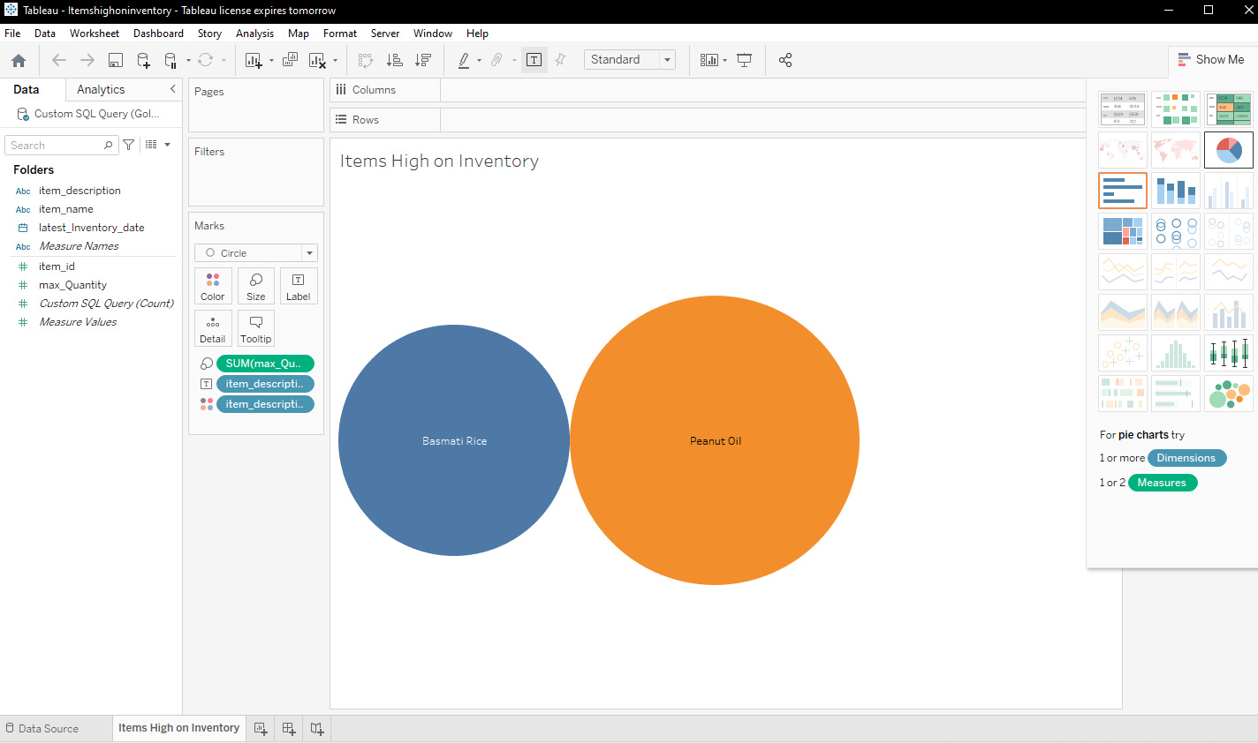

High Inventory Items

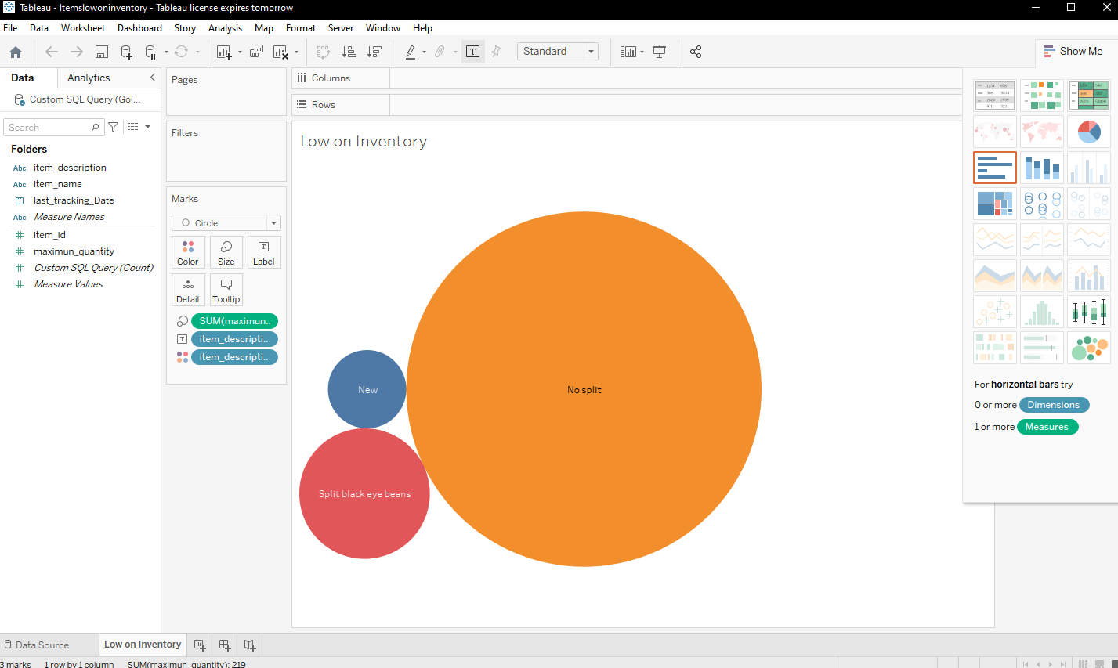

Low Inventory Items

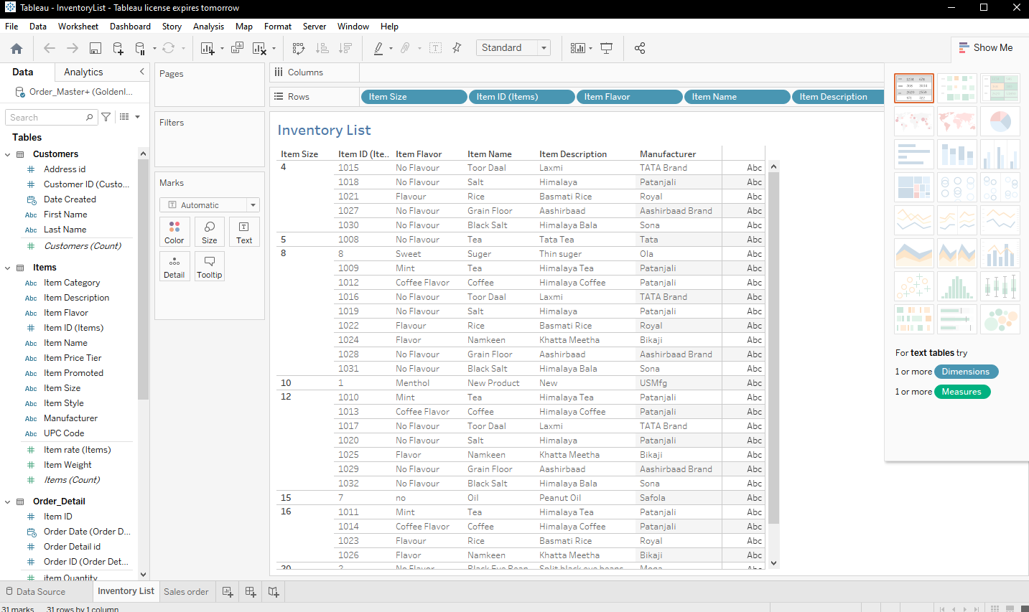

View Inventory

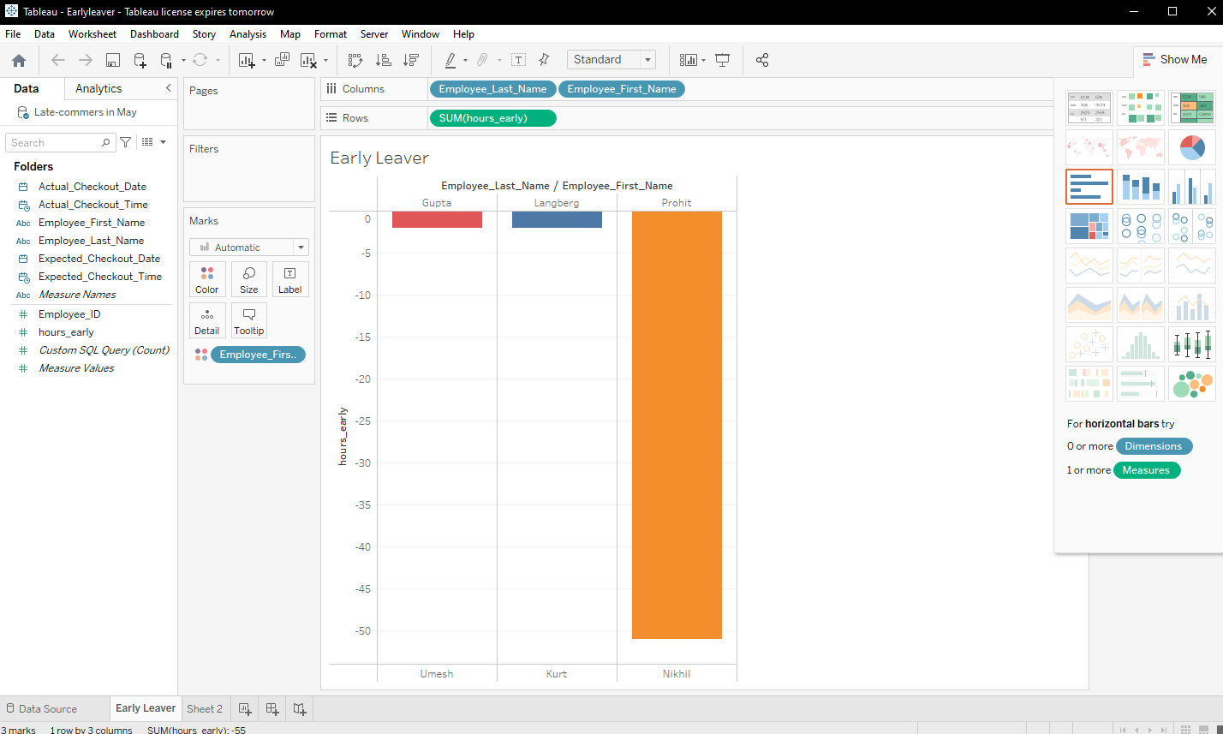

Early Leavers

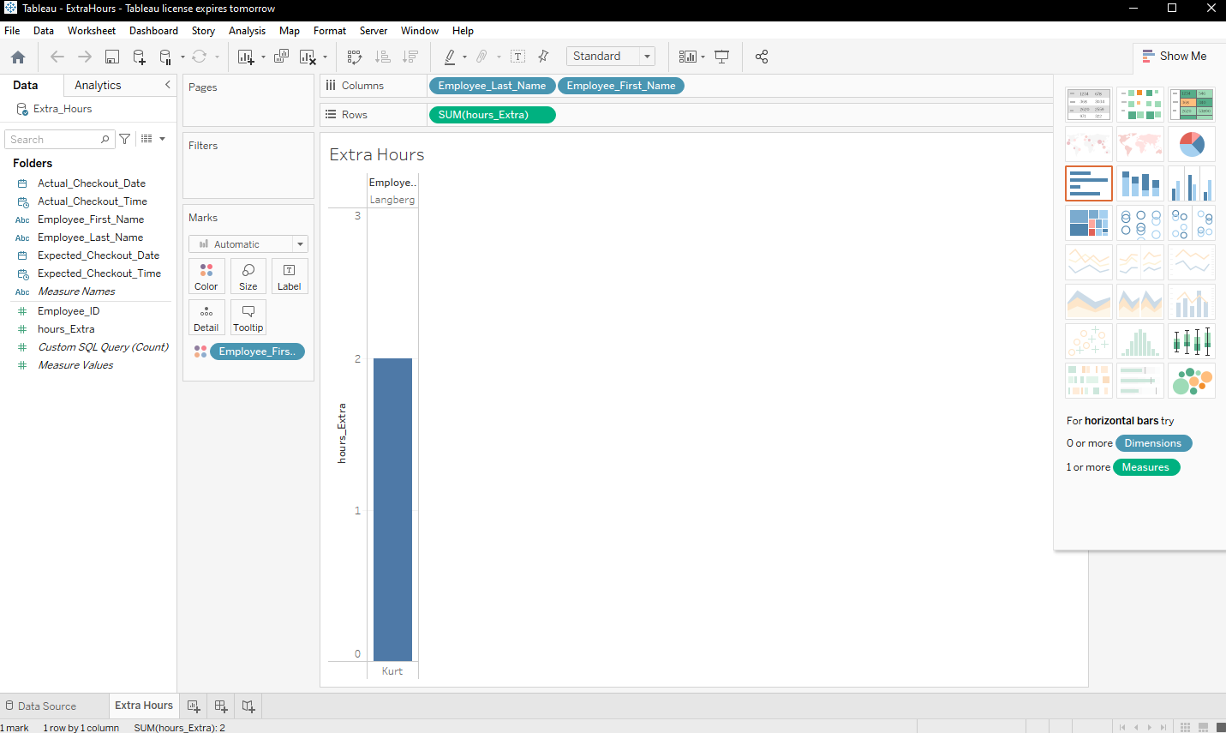

Extra Hours

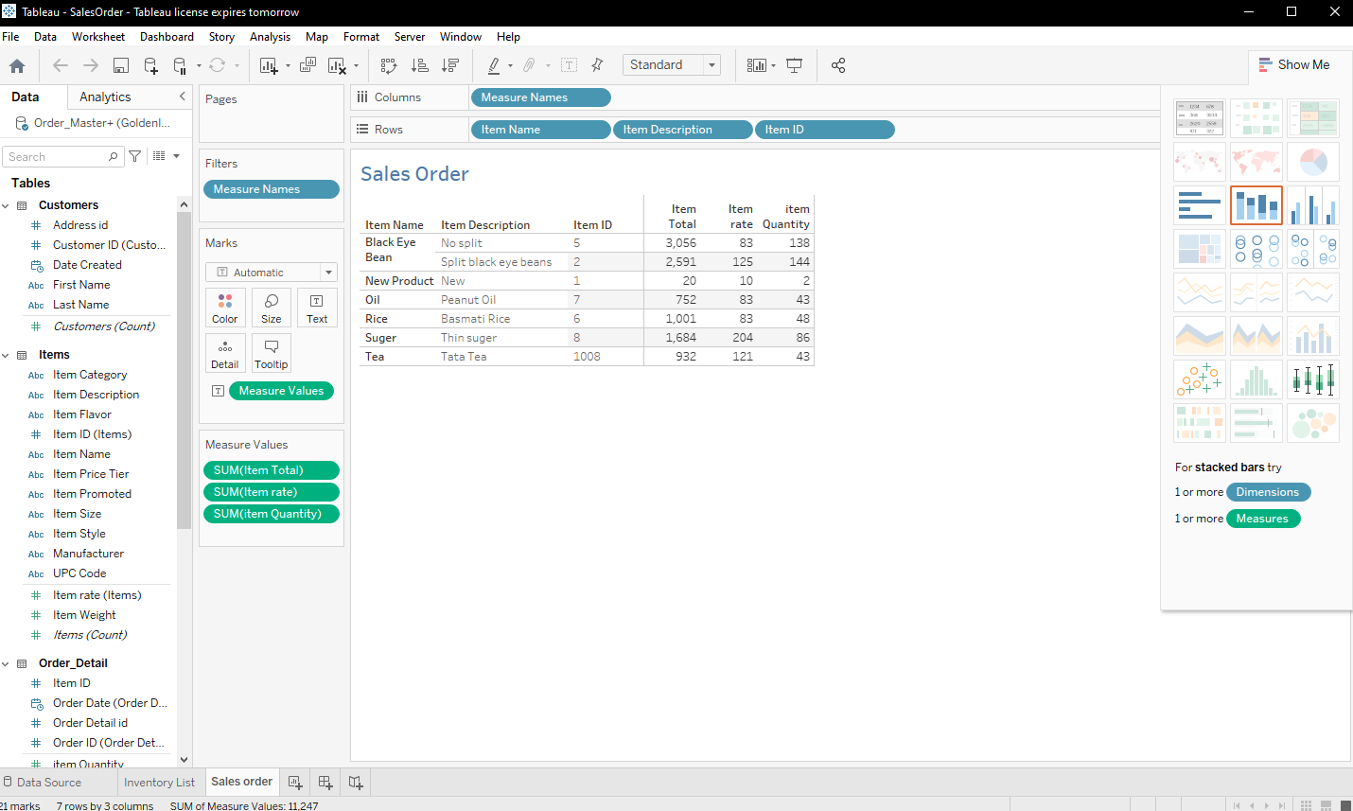

Sales Order